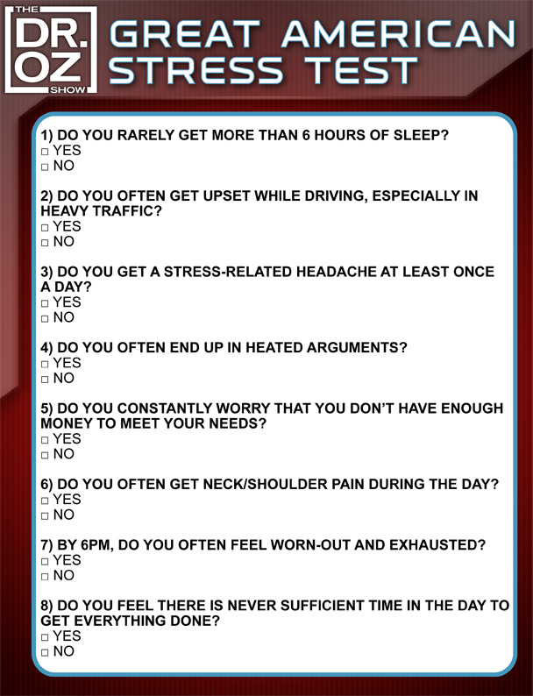

**0-1 Low Stress**

**2-4 Medium Stress**

**5-8 High Stress**